Seminar / Self-Study Handout: Walter Greenwood's Love on the Dole (1933)
Tutor: Professor Chris Hopkins (2016)
1. What did you think? Impact of language? ('dialect' and 'standard')? How does the text imagine its reader(s) do you think?
2. The Opening Chapter - function? The portrayal of Hanky Park. Is the narrator an insider or outsider to Hanky Park? How does the opening Ch relate to Ch 2?
3. Who do you think the central figure is? (if there is one – or maybe there are multiple protagonists?)
3. What kind of family are the Hardcastles? (how do names work in this novel?) Mr Hardcastle, p. 94 ('An' what have Ah t' see for it?').
4. HARRY. Image of him in Ch 2 from his interactions with Sally? His view of school, his current job and Marlowe's? (pp.19-20 Penguin edition, 1969 etc). p.22 - why not ask Ned Narkey? pp.22-3: Why ask Larry instead? but why not ask Larry instead? Clocking on number 2510 (p.26)
Harry at the pawnshop (how did/do pawnshops work?). Harry's view of the women + their lives - pp.30-33? Why so important for him to get out of the Pawnshop?
Mr Price's 'Price code', (and see explanation p.40):
S | H | U | N | P | O | V | E | R | T | Y | X
1 | 2 | 3 | 4 | 5 | 6 | 7 | 8 | 9 | 10 | 11 | 12

Clothes: shorts, suits and overalls: 'Girls make him sick': pp. 42, 43 + 46. The Good Samaritan, p.90.
At Marlowe's. The crane + foundry. pp.48-9. Being an apprentice - how good an experience for Harry? (see p. 66) but also see Larry's comments about wartime women workers and apprenticeships, p. 47. 'Time's flight', p. 74-5.
Helen's view of the world, pp. 64-5.
The thripenny treble + 'Magic Casements, p.118. How does gambling work in the economy and culture of Hanky Park? p. 125: 'now the arbiters of their own destiny'.
5. LARRY. Is he different from everybody else in Hanky Park? Does he have different origins? Or how has he become what he is? How do people see him in Hanky Park? (see pp.22-3 ' a plane above that of ordinary folk'). See rambling invitation, p. 87. See his political speech, p. 86. How effective? Sally's reaction. Romance in this novel + romance in the economy and culture of Hanky Park. See p.131 - the story of Joe Simmonds' holiday + romance (holidays are referred to a lot in the novel - why?). Why won't Larry marry Sally after he loses his job? What are Larry's politics? Labour? Communist? Is his chalk + talk better than his speech? (see p. 183).
6. SALLY. Her situation and character? Is she also an exceptional figure in Hanky Park? See p. 15 ('a face and form such as any society dame would have given three-quarters of her fortune to possess’). How significant that the novel introduces her in this way? Some development later on? Her intervention between Kate Malloy and Ned Narkey: p.167. Is she different from the other women in Hanky Park? Sally + Larry - the walk on the moors pp. 95-6. Sally and Sam Grundy.
7. The 'Chorus'. Can you tell them apart easily? Does this matter?
Mrs Jikes: ‘a transplanted sprig of London Pride from Whitechapel’ (p.37); wears a man’s cap and a shawl; referred to as ‘tiny’; tells fortunes and runs seances; plays the accordion at Mrs Scodger’s spiritualist mission. Her husband is alive, but makes little appearance in the novel.
Mrs Dorbell: ‘a beshawled, ancient lugubrious woman’ (p.32); pawns items for women too ashamed to visit Price’s pawnshop themselves, taking a commission.
Mrs Nattle: ‘a tall restless-eyed old woman, who had fetched, in a bassinette [a pram], nine suits, a dozen frocks, any number of boots and shoes, two wedding rings, [and] three watches and chains’ (p. 33); she, like Mrs Dorbell, ‘oblidges’ her neighbours, for a price, assisting with their business at the pawnshop.
Mrs Bull: ‘the local uncertified midwife and layer-out of the dead’ (p.57); referred to as ‘stout’. Has been married and bereaved, but is now married again, though her husband, ‘Jack Bull’ is mentioned only once, when Mrs Bull declines to bail him out after the protest march, if he has been arrested (p. 207).

Novel's / reader's attitude to them? e.g. ‘Some folks know how t’ make money, by gum they do! Agent for owld Grumpole’s clubs, pawnin’ for naybores, obligin’ ... and selling nips.’ (p. 105). illegality: at the pawnshop: p.34 but also comic, e.g. p.107.
Their political beliefs: Mrs Dorbel on Lloyd George, p.33; ‘Me ma and her ma was blue (Conservative) or they wus red (Liberal), just depended on which o’t’ two gev most coal an’ blankets’ (p.164). Mrs Bull: ‘Ah allus votes Labour and Ah allus will’, p.164).
The seances?
8. 'Villains'? Price, Sam Grundy? Ted Munter? Ned Narkey? Are they the main problem with Hanky Park? Why does Ned become a policeman? How does the novel present his war-service?
Blind hate and envy dominated him; his impulse was to snatch at Grundy’s throat, fling him to the floor and kick his brains out, as he had done to those German boys, who, scared stiff, he had captured in a pill-box, a feat of heroism which had earned him the medal and the commander’s commendatory remarks (p.188)
Don’t you come the bloody sergeant-major stuff on me, Meath ...Ah fought for such bastards as you. Sergeant-major Narkey that’s me. Ay an’ Ah wus o’er there while yellow-bellied rats like you wus sleepin’ wi’ owld sweats wives an’ landin’ soft jobs for y’selves (p.135).
‘You’re an owld sweat and y’ve Military Medal’...Ned licked his lips. Seventy shillings a week regular; holidays paid for and clothes free. Better than being in the army for, here, after the eight hours duty, one was a civilian again (p. 189)
How villainous is Sam Grundy in the novel? Novel's attitude towards betting?
9. The march against the Means Test. Speeches - pp.197-9. What does Larry want to achieve? Why does the novel kill Larry off? How are the police portrayed? See Ned, ‘Ah hope t’Christ the bastards start summat’ (p.198).
10. Ending: Sally's 'choice':
Sam Grundy. ..He had everything to offer; she had nothing to offer. He had money... the fast conveyance in the search for forgetfulness; money that would give the quietus to gnawing memory... Compunction pinched her as she imagined what Larry might say to this characterless capitulation to impulse... Larry? Ha! Dead, and so was Sally Hardcastle. (p.242).
Mrs Bull + Mrs Cranford on marriage:
‘Married... You ain’t missed nowt wi’ missin’ that. Oh, God, if Ah’d me time t’ go o’er agen Ah’d ne’er get wed. Naow, not t’ t’ best feller breathin wot hadn’t enough to keep me on proper. An’ Ah know o’ no married woman i’ Hanky Park wot wouldn’t do same. Marriage, eh? Yaaa. Y’ get married for love an’ find y’ve let y’sel’ in for a seven day a week job where y’ get no pay. Luk at me Sal ... Worritin’ me guts out trying t’ mek ends meet, an; a tribe o’ kids to bring up’. (p. 244).
Mr Hardcastle on respectability: ‘ “So y’d go whorin’ an’ mek respectable folk like me and y’ ma the talk of the neighbourhood, eh? Damn y’! Y’aint fit to be me dowter” ‘ (p.246).
The End: 5.30 am.
11. Is it a 'message-bearing' novel? If so, what is it trying to persuade readers of?
12. Reception. Very widely reviewed, very widely praised.
The Times quoted Sir Herbert Samuel’s plea that the entire House of Commons should ensure they had seen the stage version to enhance their understanding of what unemployment figures actually meant:
I wonder whether hon. Members have seen a play which is now being performed in London, called, "Love on the Dole." If not, I would urge them to see it. That play paints in very poignant fashion the position of those 400,000 families who are in the state which I have just described (Hansard, Parliamentary Debates, House of Commons, 5th Series, Vol 298, Col 1665, 4/3/1935)
Review of Love on the Dole in the Manchester Guardian, 30/6/1933

We passionately desire this novel to be read; it is the real thing. Mr Greenwood is a Salford man; while still at school he (like Harry in his book) worked in a pawnbroker's shop; he has been on the dole. He knows and he can tell.

In a first novel he communicates with an ease which makes him, in sheer readability, the superior of most experienced novelists. His ironically happy ending is superb; his use in the manner of a Greek chorus of the terribly - we use the word advisedly - the terribly amusing Mrs Nattle and her cronies is beautifully judged.

Mr Greenwood can find landscape in Salford for lyrical description, he can discern in Trafford Park a "Five-year Plan thirty years ahead of the Russian", he can move us almost unbearably by a hopeless love scene, he is a candid reporter of Salford conversation, a speech less toothsome than the racy Lancashire of, for example, Mr T Thompson's remoter districts, slightly flavoured, besides, by Americanese from the talkies. The authenticity is beyond dispute, and squeamish readers must lump its frankness.

"The melancholy hoot of a ship's siren sounded from the Salford Docks" - melancholy and derisive. The Ship Canal offers no escape, and those who are born in Salford stay there. "He noticed," at 17 or so, "the passing train. The incredible appreciation that he had never been aboard one in his life dawned on him, startlingly."

Yet machines had fascinated Harry Hardcastle, and, refusing the possibility of office work, he had bound himself engineer's apprentice. At 21, since well-behaved machines need only boys to tend them, he was a qualified engineer on the dole, a corner boy in love.

The book tells the story of his love for the weaver Helen, and of the love of Sally, his sister, for Larry Meath, whose practical idealism respected the notion that 45s. is a marrying wage. Meath was fatally injured in a police charge during a means test demonstration, and Sally paid for his cremation.

She paid. Sally was lovely, and of the three obscene powers of Salford, pawnbroker, moneylender, bookmaker, it is the bookmaker who is the greatest. We rather doubt if a bookmaker could recruit a man into the police; we don't doubt that the purchase of mistresses is one of the things some bookmakers do with their profits.

When early this year we read in Nobody Starves, an informing novel of depressed industry in the States, we felt a twinge of jealousy for England. Here, transcending anticipation, is the novel for which we hoped; we emphasise again its readability.

HB [known to be Harold Brighouse, Salford author of the play Hobson's Choice.]

http://www.guardian.co.uk/theguardian/2008/jun/30/7

How does Spender's poetic representation of the poor compare to Greenwood's prose version?

Stephen Spender, 'An Elementary School Classroom in a Slum' (1939)
Far far from gusty waves these children's faces.
Like rootless weeds, the hair torn round their pallor:
The tall girl with her weighed-down head. The paper-seeming
boy, with rat's eyes. The stunted, unlucky heir
Of twisted bones, reciting a father's gnarled disease,
His lesson, from his desk. At back of the dim class
One unnoted, sweet and young. His eyes live in a dream
Of squirrel's game, in tree room, other than this.
On sour cream walls, donations. Shakespeare's head,
Cloudless at dawn, civilized dome riding all cities.
Belled, flowery, Tyrolese valley. Open-handed map
Awarding the world its world. And yet, for these
Children, these windows, not this map, their world,
Where all their future's painted with a fog,
A narrow street sealed in with a lead sky
Far far from rivers, capes, and stars of words.
Surely, Shakespeare is wicked, the map a bad example,
With ships and sun and love tempting them to steal---
For lives that slyly turn in their cramped holes
From fog to endless night? On their slag heap, these children
Wear skins peeped through by bones and spectacles of steel
With mended glass, like bottle bits on stones.
All of their time and space are foggy slum.
So blot their maps with slums as big as doom.
Unless, governor, inspector, visitor,
This map becomes their window and these windows
That shut upon their lives like catacombs,
Break O break open till they break the town
And show the children to green fields, and make their world
Run azure on gold sands, and let their tongues
Run naked into books the white and green leaves open
History theirs whose language is the sun.

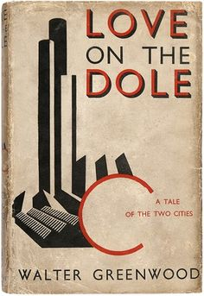 | 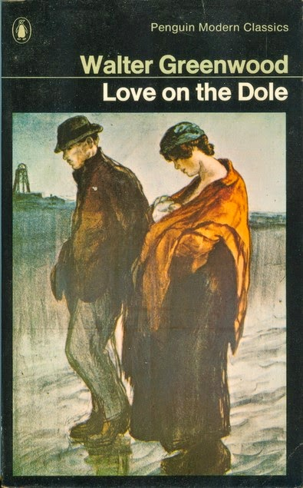
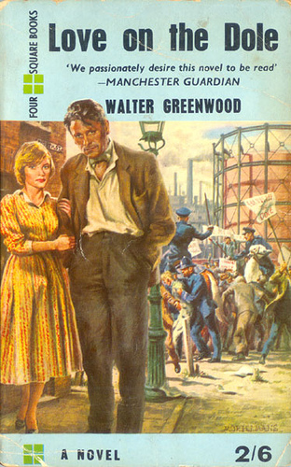 | 